**Smart Expense Tracker**

**Phase 2: Org Setup & Configuration**

* Salesforce Edition: Developer Edition / Enterprise.
* Setup company profile (working hours, fiscal year aligned with accounting cycle).
* Create Expense Manager role & profiles (Employee, Finance, Admin).
* Assign permission sets for file upload, record edit, and approval.
* Configure sandbox for development & testing.

**Company Information**

**Users**

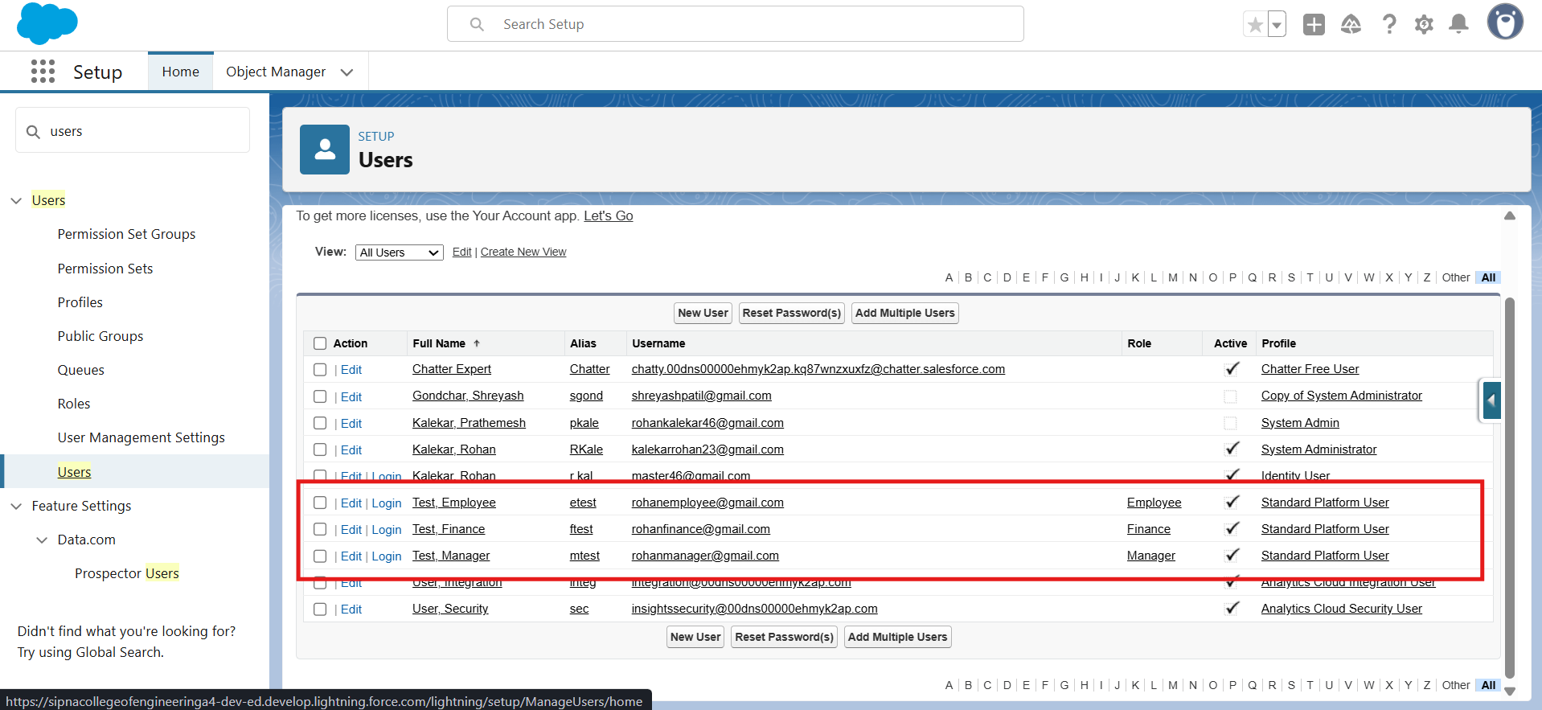

**A] Admin Page**

**B] Manager Page**

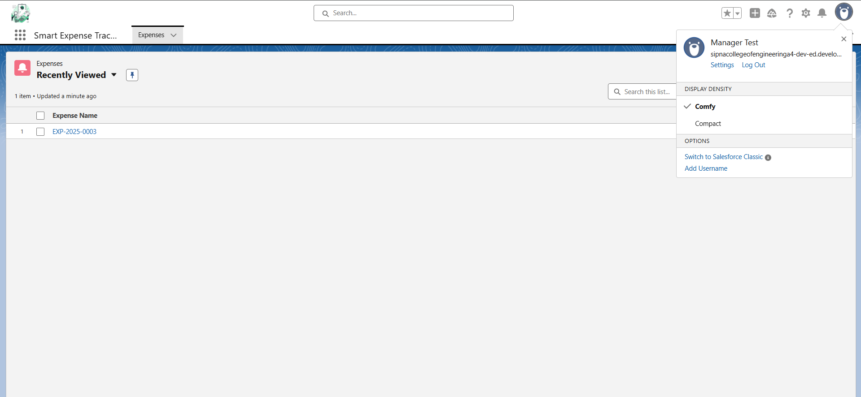

**C]Finance Page**

**D]Employee Page**

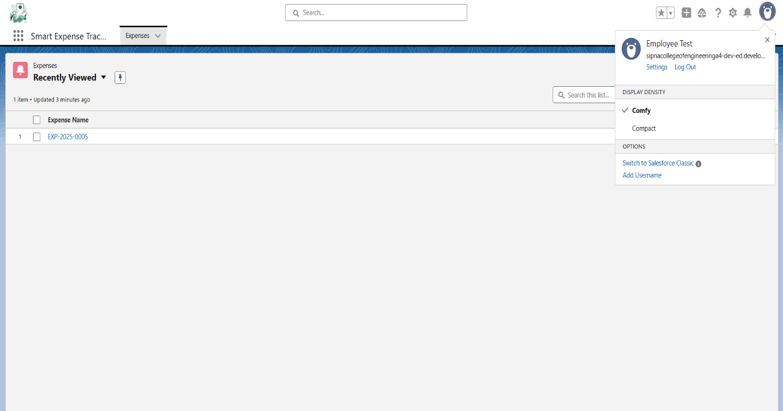

**Roles Hierarchy**

